Project Initiation Form (behavioral)

Title of project: Does emotional arousal influence metacognition for memory?

Project description and Hypothesis
Arousal (e.g., emotional and physiological) biases both perception and memory. For example, evidence from our lab and others suggests that pre-stimulus and stimulus-evoked arousal can influence both the decision criterion and confidence during perceptual decisions. Arousal exerts a well-known effect on the acuity and content of free recall, as for example in the “lightbulb” effect in which memory for traumatic, exciting, or otherwise emotionally arousing events is heightened. However, to our knowledge no experiment has investigated whether arousal also influences metacognition for memory (metamemory). This project will adapt a pre-existing task for measuring the sensitivity, bias, and efficiency of metamemory for arousing versus unarousing stimuli. Further, we will test whether stimulus-evoked heart-rate changes mediate the influence of arousal on metacognition.

Main Hypotheses
We expect that high arousal words (e.g., “abuse”, “angry”, “intercourse”) will strengthen memory recall as well as metacognition for memory (metamemory); i.e. an improved correspondence of confidence and accuracy. This will be measured by the d-prime (sensitivity) for recall accuracy, and the m-ratio for metacognitive efficiency, as estimated by a signal theoretic model of metacognition. Stimuli will be the top 250 most arousing words, divided equally by positive and negative valence, all derived from the “Affective Norms for English Words” database. Because a full-blown double translation and revalidation in Danish is not possible, all participants will be selected for having a high level of English fluency, and measures of heartrate and subjective arousal ratings by stimulus condition will provide manipulation checks. Key statistical analysis will be comprised of paired t-tests (aroused vs unaroused word blocks) on d’, confidence, m-ratio. Furthermore, we will fit a hierarchical linear model (mixed effects) describing how participants’ confidence ratings are a function of the words’ arousal levels; we predict that stimulus-evoked changes in heartrate will mediate the influence of accuracy on confidence.

Consistent with the COBIDAS guidelines for reproducibility in neuroimaging and psychological research, all core analyses, hypotheses, and associated power calculations will be pre-registered prior to data collection using the OSF template at our associated project page (https://osf.io/pefnr/). Additionally, all stimuli, task materials, and fully anonymized raw data will be made available on the OSF project website.

Deadlines:
- September 1st: Adapt task for arousal manipulation.
- October 1st - 31st: Data collection
- November – December: data analysis and interpretation
- January – submisson of thesis.
- February – preparation of preprint and journal submission at PLOS ONE or similar (note that our preregistration will help to ensure any null findings are publishable).

Paradigm structure
We will adapt a commonly used measure of meta-memory, see e.g., http://www.jneurosci.org/content/33/5/189 as a key reference. Participants will make a 2AFC judgement for item pairs, to discriminate which have been seen previously in a memorized list. We will adapt this task so that some blocks involve emotionally neutral trials and others high-arousing (positive and negative valence) words. The order of block will be pseudorandomized and counter-balanced across participants to ensure no block to block repetition of arousal condition.

Behavioral tasks. Participants p 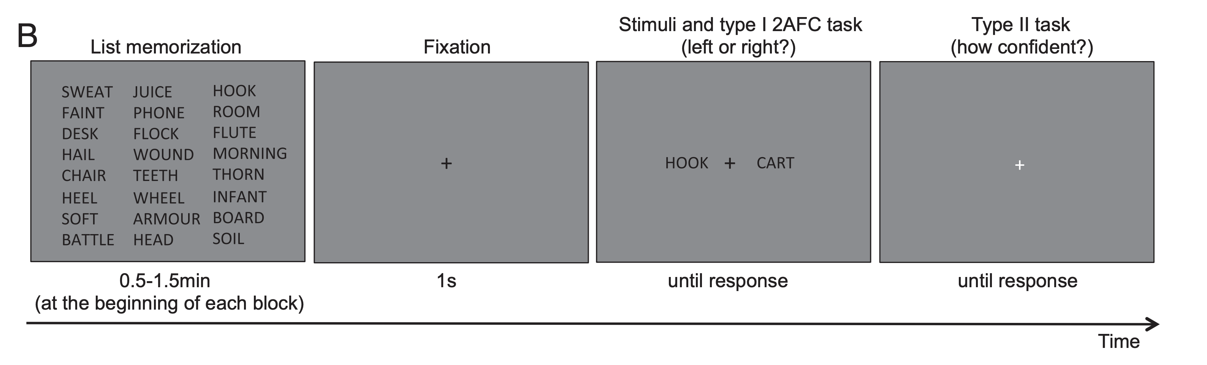-AFC tasks. A, Visual task. Participants viewed two circular stimuli that were presented
y to the left and right of fixation; one stimulus contained only visual noise, and the other
At the beginning of each block of 50 trials, participants study a list of words arranged in 10 rows and 5 columns (an 8 row × 3 column is shown here for ease of display). In each trial, participants view two words presented simultaneously to the left and right of fixation; one word had been presented on the study list and the other hand not. Participants perform a 2-AFC judgment, indicating which word (left or right) was on the previously studied list. Subsequently, participants rate how confident they were that their 2-AFC judgment was correct using a 4-point scale (not shown on the screen). Both responses have to be provided within 5 s.

Resources
Hours of pilot experiments:
Approximately 10-15h

Total number of subjects:
Healthy subjects: 35 Patients:0

Hours of pre-screening and interviewing per subject: 0.25

Hours of preparation and recording per subject (less than 1 hour is recommended): 1 hour.

Auxiliary resources
Is clinical assistance needed? Yes ☐ No x

Are injections needed? Yes ☐ No x

Is special equipment needed? Yes x No ☐

We would like to record online ECG for stimulus-evoked analyses. Additionally, if feasible we would like to record from the respiration belt so we can pilot some post-hoc measures of respiratory cycle effects.

